

**NAVI MUMBAI CAMPUS**

**Mobile Application Development Report**

**AceGATE: A Revamp of GATE Preparation**

***Prepared by:***

**Kusum Panamgipalli [A069]**

**Himanshu Rotey [A062]**

**Anshu Mehta [A123]**

**Vaishnavi Awasthi [A126]**

***Supervisor:***

**Prof. Anindita Khade**

### 

**Index**

|  |  |  |
| --- | --- | --- |
| **Sr. No.** | **Topic** | **Page No.** |
| 1. | Abstract | 3 |
| 2. | Introduction | 4 |
| 3. | Existing systems | 5 |
| 4. | Proposed System | 6 |
| 5. | Data Set/Data Collection | 7 |
| 6. | AceGATE Interface | 8 |
| 7. | Conclusion and Future Scope | 13 |
| 8. | References | 14 |

### **Abstract**

### Preparing for the Graduate Aptitude Test in Engineering (GATE) is crucial for engineering students aiming for top postgraduate programs or job placements. Effective preparation requires rigorous practice and self-assessment across key subjects, yet students often lack access to dynamic mock test tools with adjustable question difficulty, instant feedback, and detailed performance insights. To address this, an intelligent mock test application is needed to simulate the GATE exam experience, enabling students to track progress and identify areas for improvement effectively.

**Introduction**

#### The GATE Mock Test Application is a comprehensive preparation tool designed to enhance the GATE exam experience for students. The platform features distinct user logins for students, enabling them to effectively manage their preparation for the exam.

#### Students can create accounts, select the specific test category they want to attempt, and choose from three main subject areas: General Aptitude, Engineering Mathematics, and Core Computer Engineering Subjects (including Computer Networks, Data Structures and Algorithms, Theory of Computation, DBMS, and more). The application randomly generates mock tests by selecting questions from a pre-existing pool based on three difficulty levels: easy, medium, and hard. This ensures a dynamic and engaging testing experience tailored to the user's current level of preparation.

#### Each test operates under a specific time limit, and if the user remains inactive for over five minutes, the test will automatically terminate and return to the home screen, encouraging time management and simulating real exam conditions. Upon completion of each test, users receive immediate performance feedback, categorizing their results as Poor, Average, or Brilliant. They also receive a detailed report highlighting marks for each attempted question, as well as insights into areas for improvement and strengths.

**Existing Applications**

There are several applications currently available in the market designed to aid GATE (Graduate Aptitude Test in Engineering) preparation. These applications offer a variety of features aimed at improving students' performance and familiarity with the exam format. Some popular applications include:

1. Gradeup: Gradeup offers a range of features including mock tests, study materials, and daily quizzes. Its interface is user-friendly, and it provides detailed analytics after each test to help students understand their strengths and weaknesses.
2. Unacademy: Known for its video lessons, Unacademy offers interactive live classes and a vast array of practice questions tailored to GATE and other competitive exams. It has a dedicated section for GATE preparation, covering various subjects and providing mock test series.
3. Testbook: Testbook offers a vast collection of mock tests and practice questions with real-time analytics. The platform also features time-based tests to help students manage their exam time effectively, along with discussion forums for doubt resolution.
4. GATE Academy App: This app provides a mixture of video lectures, mock tests, and quizzes, as well as previous years’ question papers for GATE. It includes test series and chapter-wise quizzes to aid in comprehensive preparation.
5. Made Easy App: Made Easy offers access to a library of recorded lectures, notes, and mock tests, primarily focused on core engineering subjects. They provide video solutions for difficult questions, which are useful for understanding complex topics.

**Proposed GATE Mock Test Application**

The GATE Mock Test Application we propose aims to stand out by offering a highly personalized and dynamic approach to test preparation. This application focuses on delivering a tailored experience based on the student’s progress, providing a more strategic pathway to exam readiness.

Key features of our application include:

1. **User-Specific Accounts**: Students can create personalized accounts, allowing them to save progress, access their performance history, and receive suggestions based on their unique strengths and areas for improvement.
2. **Category and Subject Selection**: Users can choose their desired test category and select from three main subject areas:
   * *General Aptitude*
   * *Engineering Mathematics*
   * *Core Computer Engineering Subjects*
3. **Dynamic Test Generation**: The application will generate mock tests dynamically by selecting questions from a pre-existing pool based on three difficulty levels: easy, medium, and hard. This feature will enable students to practice tests that match their current level, helping them gradually advance to more challenging questions.
4. **Time-Management Features**: Each mock test is time-bound to simulate real exam conditions, promoting effective time management. If a user is inactive for over five minutes, the test will automatically end, helping students get accustomed to the pressure of maintaining focus during the exam.
5. **Immediate Performance Feedback**: After completing a test, students receive instant feedback. The results categorize their performance as Poor, Average, or Brilliant and provide insights into their strengths and areas needing improvement. This feature is designed to be motivational, pushing students to progress with a clear understanding of what they need to work on.

**Data Set Collection**

We had collected many questions from Sample Question Papers of mock tests, which we had converted into a JSON file.   
The hyperlink is below:  
C:\Users\anshu\OneDrive\Desktop\MAD\Q_A.json

In the Dataset we had inserted correct answers which shall verify with the input answers by the user. Based on that marks we calculated and displayed.

The sample Question Papers are:  
1. GATE 2021 Computer Science Engineering by [www.gateacademy.co.in](http://www.gateacademy.co.in)

2. GATE 2022 Computer Science Engineering by [www.gateacademy.co.in](http://www.gateacademy.co.in)

**AceGATE Interface**

1. 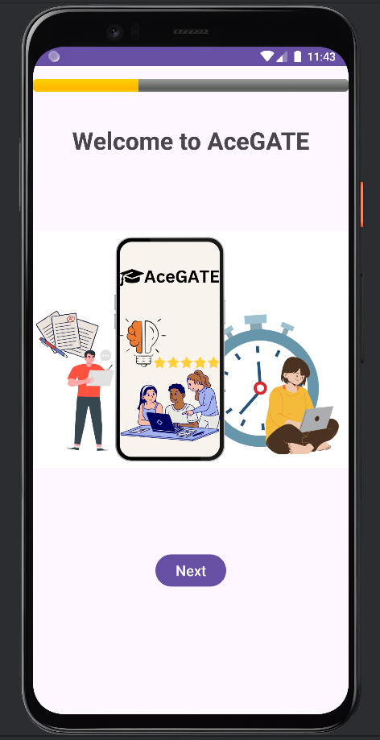 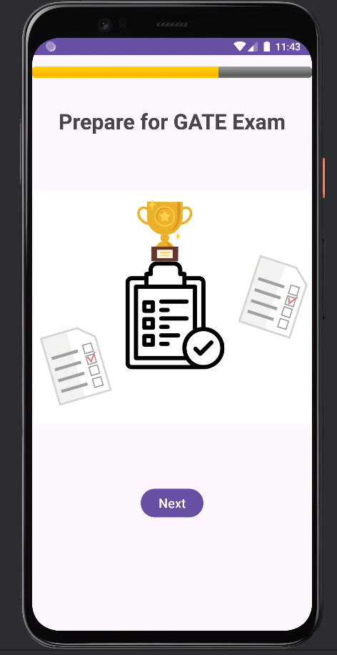 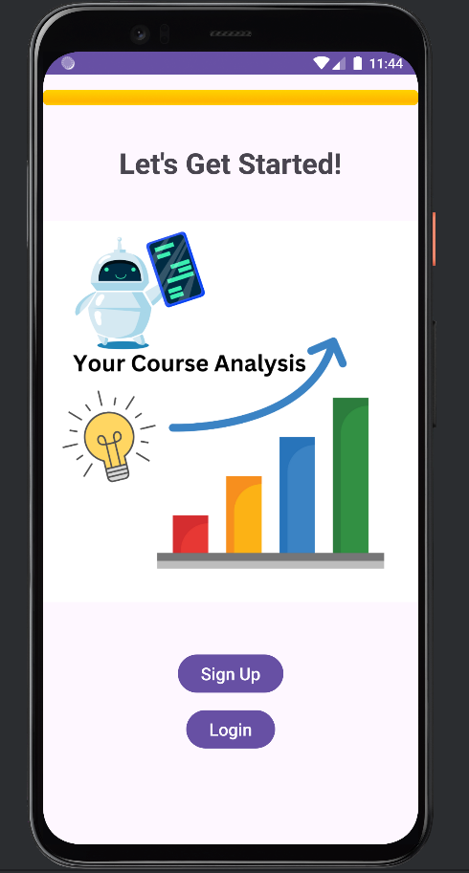
2. 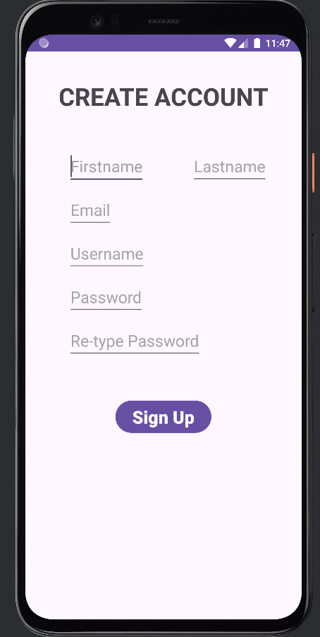 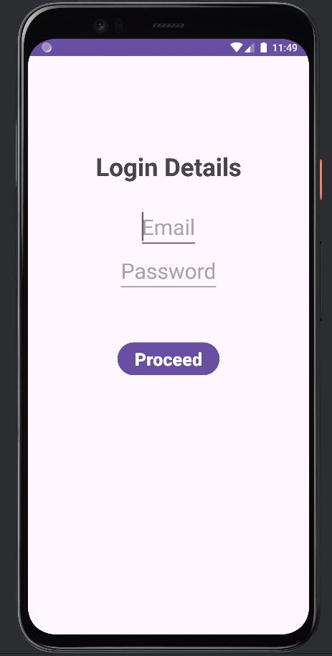 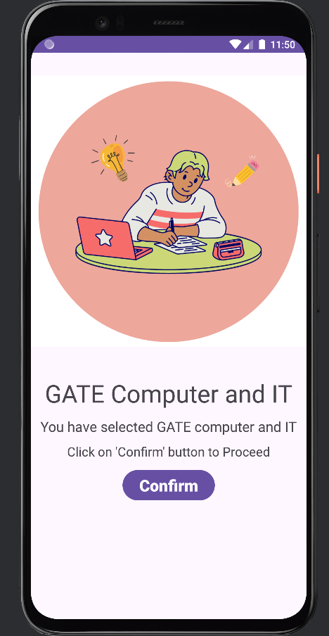
3. 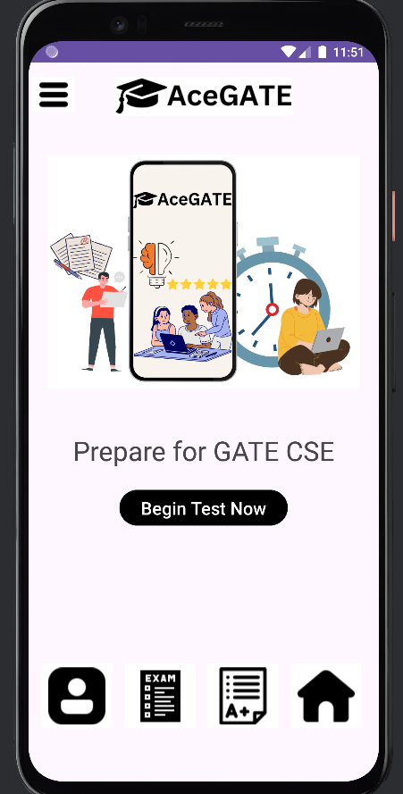 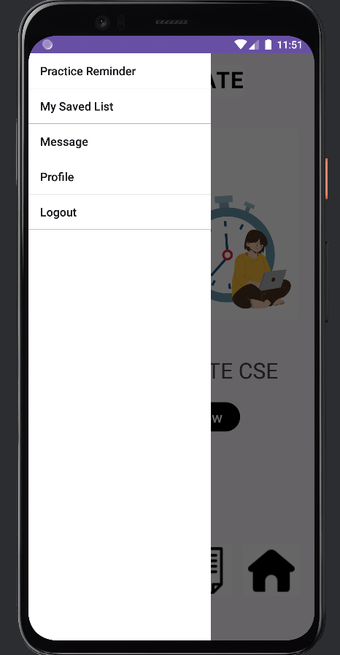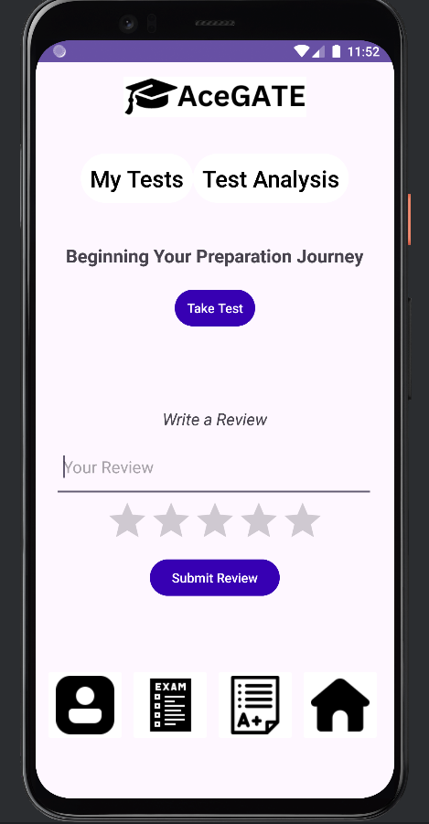 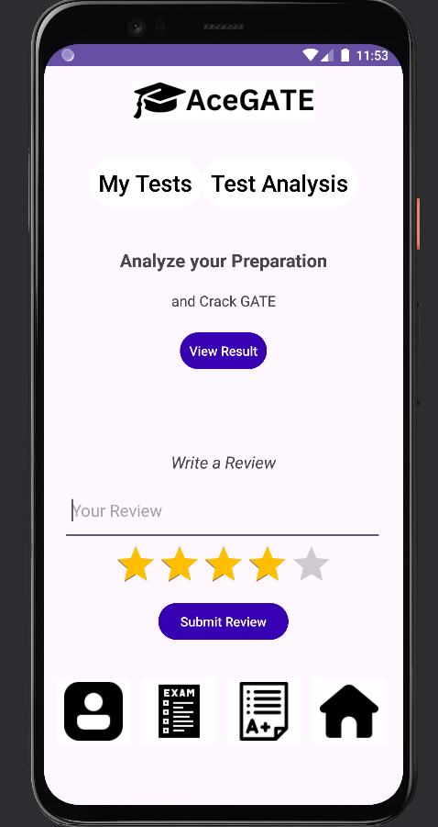 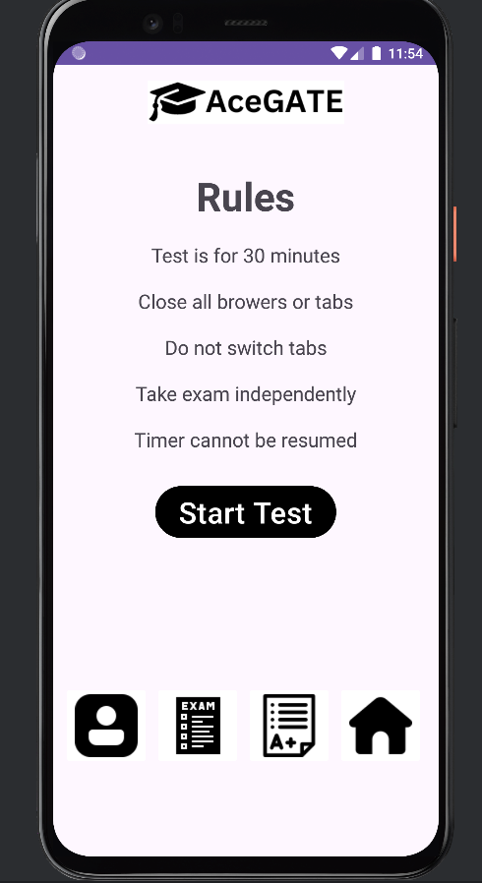 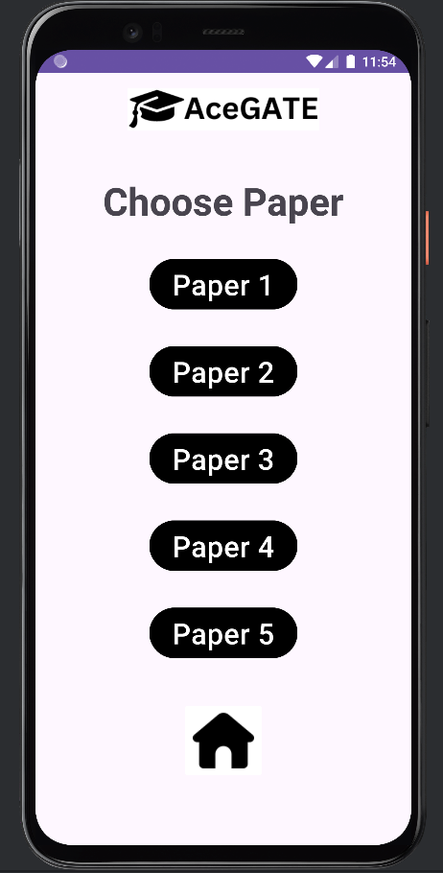 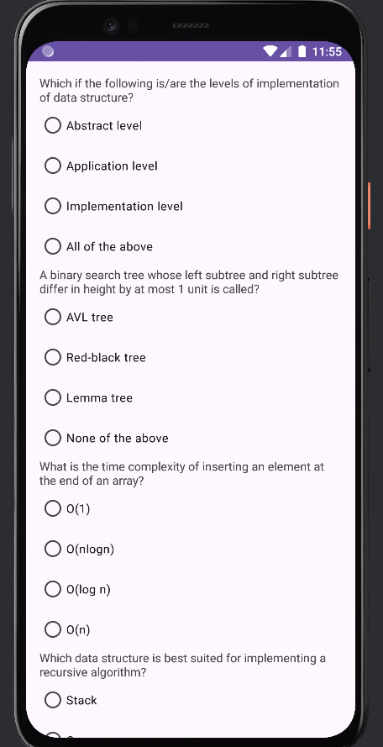 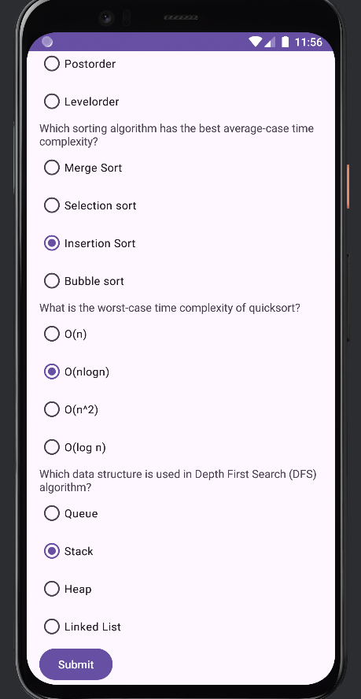 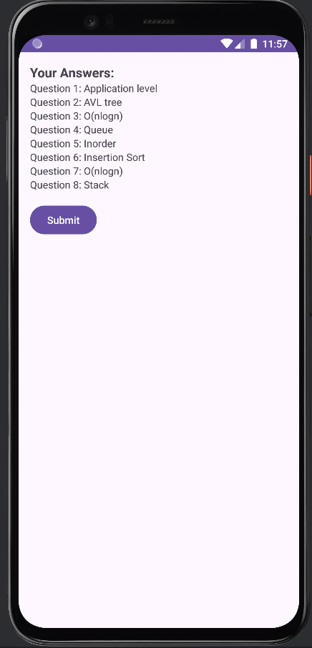 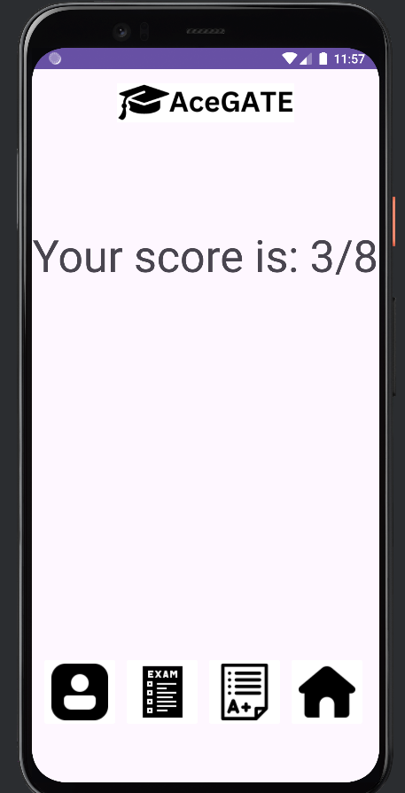

**Future Scope of the Application**

The GATE Mock Test Application has exciting potential for future expansion, aiming to elevate the user experience through AI-driven recommendations, which would analyze individual performance trends and suggest tailored study materials, topics, or difficulty levels to help students focus on weak areas. Beyond its initial core computer engineering focus, the app could broaden its subject coverage to include Civil, Mechanical, and Electrical Engineering, thus reaching a larger audience of GATE aspirants. Adding video solutions for complex questions would deepen understanding, while interactive forums and group study features could foster peer collaboration and a competitive edge. Integration with platforms like LinkedIn would allow users to showcase achievements to potential employers or graduate programs, while offline access and downloadable content would make the app accessible to students with limited internet connectivity. These enhancements aim to create a highly effective, inclusive, and engaging preparation tool.

**Conclusion**

The GATE CSE Mock Test App AceGATE provides a streamlined, focused tool for CSE students preparing for GATE. With its curated question bank, automated grading, and performance analytics, it offers an efficient way for students to measure and improve their readiness for the GATE exam. Its focus on GATE CSE specifically sets it apart from more generalized solutions, making it a valuable resource for targeted exam preparation.

**References**

1. [**https://collegedunia.com/exams/gate/mock-test**](https://collegedunia.com/exams/gate/mock-test)
2. [**https://edurev.in/home**](https://edurev.in/home)
3. **2021q&a[1].pdf**
4. [**www.gateacademy.co.in**](http://www.gateacademy.co.in)
5. C:\Users\anshu\OneDrive\Desktop\MAD\Q_A.json